- Ice breaker question

- https://www.youtube.com/watch?v=jSw7DIFQMH0
- Elon musk one minute rule
- To do list to what matters list
- What is the one problem in your life that if solved would change everything else
- What am I pretending not to know
- What if I just had one clean hour a day. No interruptions
- Experience is like a comb which gets into hand after getting bald head
- General/Personal:
- If you could have any superpower, what would it be and why?
- What is a skill you'd love to learn, and what steps would you take to learn it?
- What's a lesson you learned the hard way?
- What's a childhood dream you still hold onto?
- If you could have dinner with any historical figure, who would it be and why?
- What's a book, movie, or song that has significantly impacted you?
- What's your favorite way to relax and recharge?
- What's a small act of kindness that made a big difference in your day?
- Thought-Provoking/Opinion-Based:
- Is it better to be feared or loved?
- What is more important: success or happiness?
- What is a common misconception about your profession or field?
- What is one thing you would change about the world?
- What is the most valuable thing you own?
- If you could give one piece of advice to your younger self, what would it be?
- What is a quality you admire most in others?
- Creative/Imaginative:
- If you could travel to any fictional world, which one would you choose and why?
- Describe your perfect day.
- What is your favorite way to express yourself creatively?
- If you could have any job for a day, what would it be?
- If you could invent a new holiday, what would it be called and how would it be celebrated?
- Tell a short story incorporating the words: "unexpected", "journey", and "treasure".General/Personal:
- If you could have any superpower, what would it be and why?
- What is a skill you'd love to learn, and what steps would you take to learn it?
- What's a lesson you learned the hard way?
- What's a childhood dream you still hold onto?
- If you could have dinner with any historical figure, who would it be and why?
- What's a book, movie, or song that has significantly impacted you?
- What's your favorite way to relax and recharge?
- What's a small act of kindness that made a big difference in your day?
- Thought-Provoking/Opinion-Based:
- Is it better to be feared or loved?
- What is more important: success or happiness?
- What is a common misconception about your profession or field?
- What is one thing you would change about the world?
- What is the most valuable thing you own?
- If you could give one piece of advice to your younger self, what would it be?
- What is a quality you admire most in others?
- Creative/Imaginative:
- If you could travel to any fictional world, which one would you choose and why?
- Describe your perfect day.
- What is your favorite way to express yourself creatively?
- If you could have any job for a day, what would it be?
- If you could invent a new holiday, what would it be called and how would it be celebrated?
- Tell a short story incorporating the words: "unexpected", "journey", and "treasure".
- For example, for an in-person class room session , you can divide your people into groups and ask them to brain storm and come up with each barrier. What are psychological barriers you can think of ?
- What are cultural barriers you can think of ?
- What organizational barriers

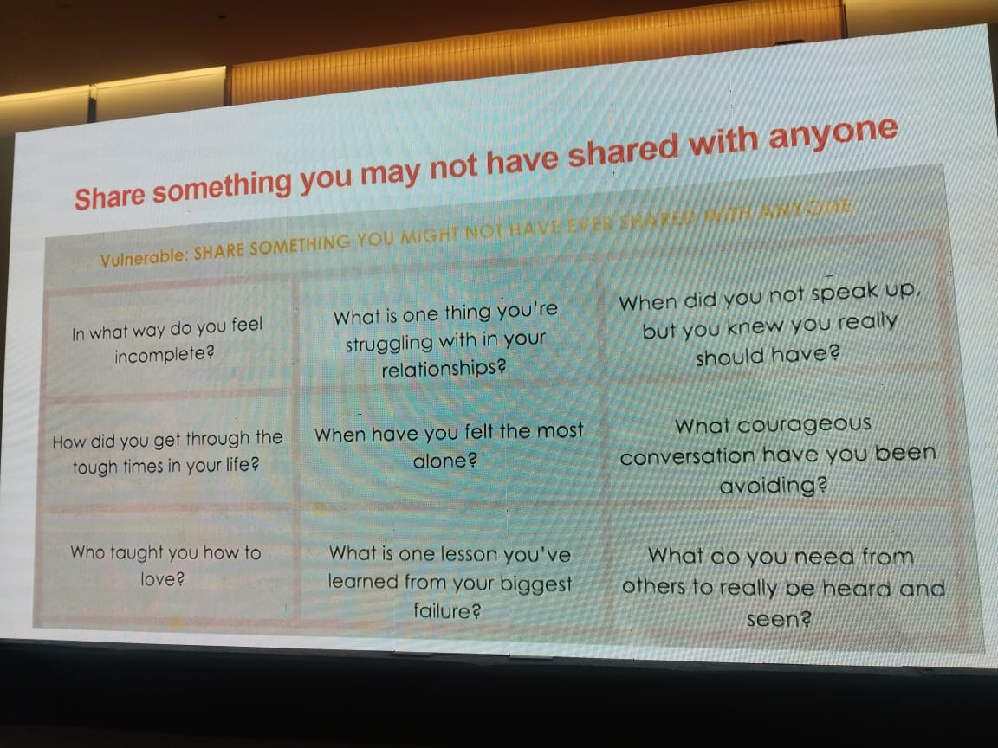

- What cause you to immediately stop being friends with someone

